|  |
| --- |
|  |
| Laboratory #4 |
| JFET |
|  |
| **Group Members:**  **Steven Le**  **Annie Bui**  **Jon Nguyen**  **Kevin Elevado** |
| **21 March 2013** |

**Introduction:**

This lab is on **junction gate field-effect transistor**s. Using a junction gate field-effect transistor, we are to observe and understand how one functions on a circuit. Based on the worksheets given by the instructor, we were to follow the procedures and answer the question on the sheets.

**Procedure:**

This lab is set up with building a circuit displayed below. Equipment required are the oscilloscope, probes, function generator (BK Precision 4017B), 100kΩ, 1kΩ resistors, and a 2N3904 transistor. After wiring everything, start the voltage at 24 volts for VDD and VGG to 0 volts. Measure these values and record readings for IG, ID, and IS. Repeat process with VGG adjusted to -1.0, -1.5, -2.0 volts with increments of -0.5 volts until drain current ID = 0 volts. After completing this, repeat the same for VDD = 1, 2, 4, 6, 8, 10, 12, 14, 16, 18, 20, 22, 24 volts.

**Instructor Procedures:**

1. Connect the circuit as shown
2. Adjust VDD to 24V, adjust VGG to 0 V.
3. Measure VGS and VDS. Record these values.
4. Calculate and record IG, ID, and IS.
5. Repeat steps 3 thru 4 for VGG = -1.0, -1.5, -2.0 volts, and so on in increments of -0.5 volts until ID = 0 volts. Record this data in table 1
6. Repeat steps 3 and 5 for VDD = 1, 2, 4, 6, 8, 10, 12, 14, 16, 18, 20, 22 and 24 V. Record this data in table 2.
7. Using the data collected in table 1 graph the drain current (ID) vs the gate-source voltage drop (VGS).
8. Using the data collected in table 2 graph the drain current (ID) vs the drain-source voltage drop (VDS) for each value of VGS (three lines).
9. For each of the graphs answer the following questions.

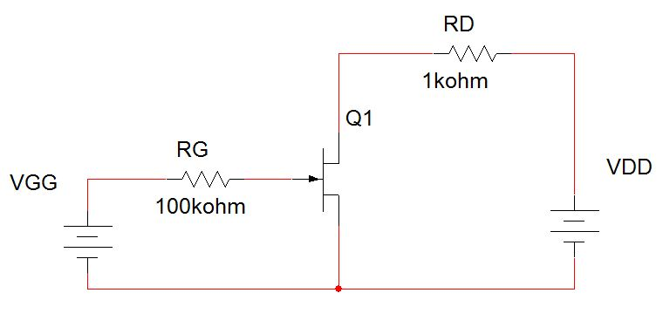

**Data:**

|  |  |  |  |  |  |  |
| --- | --- | --- | --- | --- | --- | --- |
| **VDD(V)** | **VGG(V)** | **VGS(V)** | **VDS(V)** | **IG(A)** | **ID(A)** | **IS(A)** |
| 24 | 0 | 0.002015 | 20.202 | 2.02E-08 | 0.003798 | 0.003798 |
| 24 | -1 | -0.9999 | 23.805 | -1E-05 | 0.000195 | 0.000185 |
| 24 | -1.5 | -1.5 | 24 | -1.5E-05 | 0 | -1.5E-05 |
| 22 | 0 | 0.001827 | 18.3 | 1.83E-08 | 0.0037 | 0.0037 |
| 22 | -1 | -0.9999 | 21.811 | -1E-05 | 0.000189 | 0.000179 |
| 22 | -1.5 | -1.5 | 22 | -1.5E-05 | 0 | -1.5E-05 |
| 20 | 0 | 0.001638 | 16.398 | 1.64E-08 | 0.003602 | 0.003602 |
| 20 | -1 | -0.9999 | 19.816 | -1E-05 | 0.000184 | 0.000174 |
| 20 | -1.5 | -1.5 | 20 | -1.5E-05 | 0 | -1.5E-05 |
| 18 | 0 | 0.001449 | 14.496 | 1.45E-08 | 0.003504 | 0.003504 |
| 18 | -1 | -0.9999 | 17.821 | -1E-05 | 0.000179 | 0.000169 |
| 18 | -1.5 | -1.5 | 18 | -1.5E-05 | 0 | -1.5E-05 |
| 16 | 0 | 0.001256 | 12.595 | 1.26E-08 | 0.003405 | 0.003405 |
| 16 | -1 | -0.9999 | 15.826 | -1E-05 | 0.000174 | 0.000164 |
| 16 | -1.5 | -1.5 | 16 | -1.5E-05 | 0 | -1.5E-05 |
| 14 | 0 | 0.001075 | 10.693 | 1.08E-08 | 0.003307 | 0.003307 |
| 14 | -1 | -0.9999 | 13.831 | -1E-05 | 0.000169 | 0.000159 |
| 14 | -1.5 | -1.5 | 14 | -1.5E-05 | 0 | -1.5E-05 |
| 12 | 0 | 0.000888 | 8.791 | 8.88E-09 | 0.003209 | 0.003209 |
| 12 | -1 | -0.9999 | 11.836 | -1E-05 | 0.000164 | 0.000154 |
| 12 | -1.5 | -1.5 | 12 | -1.5E-05 | 0 | -1.5E-05 |
| 10 | 0 | 0.0007 | 6.89 | 7E-09 | 0.00311 | 0.00311 |
| 10 | -1 | -0.9999 | 9.841 | -1E-05 | 0.000159 | 0.000149 |
| 10 | -1.5 | -1.5 | 10 | -1.5E-05 | 0 | -1.5E-05 |
| 8 | 0 | 0.0005 | 4.989 | 5E-09 | 0.003011 | 0.003011 |
| 8 | -1 | -0.9999 | 7.846 | -1E-05 | 0.000154 | 0.000144 |
| 8 | -1.5 | -1.5 | 8 | -1.5E-05 | 0 | -1.5E-05 |
| 6 | 0 | 0.000307 | 3.088 | 3.07E-09 | 0.002912 | 0.002912 |
| 6 | -1 | -0.9999 | 5.851 | -1E-05 | 0.000149 | 0.000139 |
| 6 | -1.5 | -1.5 | 6 | -1.5E-05 | 0 | -1.5E-05 |
| 4 | 0 | 0.000126 | 1.201 | 1.26E-09 | 0.002799 | 0.002799 |
| 4 | -1 | -0.9999 | 3.857 | -1E-05 | 0.000143 | 0.000133 |
| 4 | -1.5 | -1.5 | 4 | -1.5E-05 | 0 | -1.5E-05 |
| 2 | 0 | 3.99E-05 | 0.439897 | 3.99E-10 | 0.00156 | 0.00156 |
| 2 | -1 | -1 | 1.862 | -1E-05 | 0.000138 | 0.000128 |
| 2 | -1.5 | -1.5 | 2 | -1.5E-05 | 0 | -1.5E-05 |
| 1 | 0 | 2.58E-05 | 0.203603 | 2.58E-10 | 0.000796 | 0.000796 |
| 1 | -1 | -1 | 0.864298 | -1E-05 | 0.000136 | 0.000126 |
| 1 | -1.5 | -1.5 | 1 | -1.5E-05 | 0 | -1.5E-05 |

**Graphs**:

**ID vs VGS**

**ID vs VDS**

**Questions:**

1. At what value of VGS is ID maximum?

The drain current is at maximum when the voltage from ground-source is 0 volts.

1. What is the term used to describe this maximum drain current?

The term used to describe this maximum drain current is IDSS.

1. When VGG is 0 volts the gate source junction is considered to have what kind of bias (reverse bias, no bias or forward bias)?

The gate source junction has no bias when VGG is 0 volts.

1. When VGG is -1 volts the gate source junction is considered to have what kind of bias (reverse bias, no bias or forward bias)?

The gate source junction has reverse bias when VGG is -1 volt.

1. Which type of device is an n-channel JFET, depletion mode or enhancement mode?

The n-channel JFET is a depletion mode type.

1. When the gate-source voltage increases on an n-channel JFET, does the drain current increase or decrease?

When gate-source voltage increases on an n-channel JFET, the drain current decreases in the circuit.

**Conclusion:**

The purpose of this lab is to be exposed to JFET transistors and how it can be used in application as a depletion mode type. Current flows from source to drain and visa versa depending on the application. Current allowed though a JFET transistor is maximum through source and drain when no voltage is applied. The main concept is by applying voltage to the gate terminal, current is restricted or even switched off similar to pinching a pressurized garden water hose. In our application of an n-channel JFET, a negative gate-source voltage VGS will switch it off.